
TEMASEK JUNIOR COLLEGE
CHEMISTRY 9647/03
Higher 2

Paper 3 Free Response

Thursday 16th SEPTEMBER 2010 2 hours

Candidates answer on separate paper.

Additional materials: Answer paper
Data Booklet

READ THESE INSTRUCTIONS FIRST

Write your name & Civics Group in the spaces provided on the cover page provided and on all the work you hand in.
Write in dark blue or black pen on both sides of the paper.
You may use a soft pencil for any diagrams, graphs or rough working.
Do not use staples, paper clips, highlighters, glue or correction fluid.

Answer any four questions.
A Data Booklet is provided.
You are reminded of the need for good English and clear presentation in your answers.

The number of marks is given in brackets [ ] at the end of each question or part question.
At the end of the examination, fasten all your work securely together.

This question paper consists of 11 printed pages.
Answer any four questions

1 | (a) | The 2009 Singapore Grand Prix, held on 27th September 2009, was the fourteenth race of the 2009 Formula One season. The race was won by McLaren-Mercedes driver and reigning world champion Lewis Hamilton. Formula One cars run on petrol. Petrol is actually a mixture of compounds, but assume for this problem that petrol is pure liquid octane (C₈H₁₈).
 |  | (i) | Define the term standard enthalpy change of combustion.
 |  | (ii) | Use the data in the table below to calculate the enthalpy change of combustion of octane. Hence calculate the heat evolved per gram of octane.
  species | ΔH_{f} / kJ mol⁻¹
  C₈H₁₈(l) | -269
  CO₂(g) | -394
  H₂O(l) | -286
 |  | (iii) | Methanol, CH₃OH, is also commonly used as a fuel for high-performance engines in race cars. Due to the high temperatures in car engines, methanol is converted to the vapour state. Use the bond energies given in the Data Booklet to calculate the enthalpy change of combustion of methanol. Hence calculate the heat evolved per gram of methanol.
 |  | (iv) | Using your answers in (a)(ii) and (a)(iii), suggest an advantage of using petrol over methanol as the fuel in Formula One cars.
 |  |  |  |  | [8]
 | (b) | Compound A, C₈H₁₈, is a singly branched isomer of octane. A undergoes free radical substitution with chlorine gas to form B, C₈H₁₇Cl, an achiral alkyl halide. When B is refluxed with alcoholic potassium hydroxide, isomers C, D and E, C₈H₁₆, are formed. On reaction with hot concentrated acidic potassium manganate(VII), both C and D give 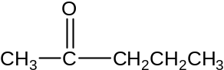 as one of the products. Deduce the structures of compounds A to E. Explain.
 |  |  |  |  | [7]
 | (c) | In American open-wheel racing, alcohol-based fuels like methanol and ethanol are used as they burn more smoothly than petrol. Alcohols can also be used to synthesize ethers, ROR’, through the Williamson synthesis. This synthesis involves the reaction of sodium alkoxide, RO⁻Na⁺, with an alkyl halide, R’X, as shown below.  RO⁻Na⁺ + R’X → ROR’ + NaX
 |  | (i) |  | Draw the structural formula of the organic product formed from reaction of sodium ethoxide with bromoethane, CH₃CH₂Br.
 |  | (ii) |  | In Williamson synthesis, the alkyl halide can also undergo elimination as a side reaction. Draw the structural formula of the organic product formed when bromoethane undergoes elimination.
 |  | (iii) |  | Using a method similar to the Williamson synthesis, suggest how epoxyethane can be synthesized from ethanol. Indicate reagents and conditions you would use for each step and show the structures of the intermediates clearly.  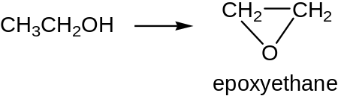
 |  | (iv) |  | Suggest why the yield of epoxyethane is low in the synthesis proposed in (c)(iii).
 |  |  |  |  | [5]
 |  |  |  | [Total: 20 ]

2 | 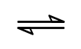  The use of lead-free petrol necessitates the production of organic compounds to produce fuels with octane numbers greater than 100. Methylbenzene has an octane number of 120 and is made by cyclising and dehydrogenating heptane.  C₇H₁₆ (g) C₇H₈ (g) + 4H₂ (g) ΔH = +ve
 | (a) | In a typical plant, heptane vapour is mixed with an inert carrier gas at only atmospheric pressure and passed over a catalyst at 300 °C.
 |  | (i) | State Le Chatelier’s Principle.
 |  | (ii) | Suggest reasons why these operating conditions are used.
 |  |  | [4]
 | (b) | It is decided to operate the plant so that 90% of the heptane is converted into methylbenzene at 300 °C. The K_{p} for the reaction is 1 atm⁴.
 |  | (i) | Write an expression for K_{p}.
 |  | (ii) | Calculate the total pressure that will produce a 90% conversion at 300 °C.
 |  | [5]
 | (c) | Name and outline the mechanism involved in the preparation of 2-nitromethylbenzene from methylbenzene.
 |  |  |  | [4]
 | (d) | Suggest how 2-nitromethylbenzene could be converted into  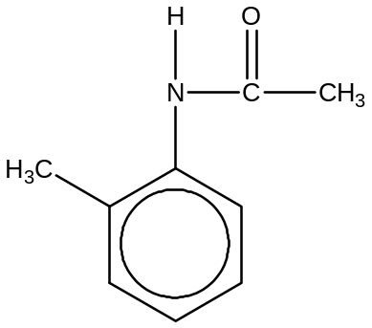  State the reagents and conditions needed in each step.
 |  |  |  | [3]
 | (e) | Concerns over the presence of bromate(V) ions, BrO₃–, in water come several months after cancer-causing substance, benzene, was discovered in batches of US soft drinks.  Long-term exposure to bromate(V) ions may increase consumers' risk of cancer, according to the US government's Environmental Protection Agency.  Aqueous bromate(V) ions acts as a strong oxidising agent in acidic solution as shown in the equation below:  2BrO₃– (aq) + 12H⁺ (aq) + 10e Br₂ (aq) + 6H₂O (l) E^{θ} = + 1.48 V  Use the Data Booklet to predict and explain what you would expect to observe when acidified bromate(V) ions are added to excess zinc. Write balanced equation(s) for the reaction(s) that occur.
 |  | [4]
 |  |  |  | [Total: 20]

3 | Chromium is classified as transition metal and has been shown to be an essential element in assisting the body to break down carbohydrates and reducing sugar cravings. For these reasons, manufacturers are adding a variety of chromium complexes to some of their bottled water products.  Other chromium compounds such as chromium(VI) oxide and ammonium dichromate(VI) are widely used in audio cassette and photography industries.
 | (a) | (i) | What do you understand by the term transition element?
 |  | (ii) | Give the electronic configuration of chromium atom.
 |  | (iii) | Predict the likely oxidation states of chromium.
 |  |  |  | [3]
 | (b) | The formula of one of the chromium(III) complexes is [Cr(C₆H₄NO₂)₃], where C₆H₄NO₂─ is the picolinate ion. Picolinate acts as a bidentate ligand and has the structure shown below.  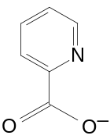
 |  | (i) | Describe and explain the features of the picolinate ion that enable it to act as a bidentate ligand. Hence, state the type of bond formed between the ligand and the central chromium ion.
 |  | (ii) | Give the coordination number of the complex and state its shape.
 |  |  |  | [3]
 | (c) | The chromium picolinate complex is soluble in water and the visible absorption spectrum of the complex is shown below:  [A visible absorption spectrum is a graph depicting the absorption of radiation by a material over a range of visible light wavelengths.]  Relative absorbance  300 400 500 600 700  wavelength  White light spectrum  700 600 500 400 300  Red green blue violet  Wavelength/nm
 |  | (i) | What is the colour of chromium picolinate complex?
 |  | (ii) | Explain why the chromium complex is coloured?
 |  |  |  | [4]
 | (d) |  | One reason for choosing the picolinate ion as ligand is that it is a breakdown product of the essential amino acid tryptophan. Tryptophan is involved in human food metabolism. Suggest why chemists thought that picolinate would be a suitable ligand?
 |  |  |  | [1]
 | (e) |  | ‘Chromium oxide’ cassette tapes contain CrO₂, an unusual oxide of chromium. This oxide is both highly conductive and ferromagnetic, and provides a good high audio frequency response.  When the oxide from a length of tape is dissolved in sulfuric acid, disproportionation to Cr³⁺ and Cr₂O₇^{2─} occurs. The resulting solution needed 10.0 cm³ of 0.02 mol dm⁻³ Fe²⁺(aq) to reduce completely the Cr₂O₇^{2─} to Cr³⁺.
 |  | (i) | Suggest equations for the disproportionation of CrO₂ in acid solution, and for the reaction of Cr₂O₇^{2─}(aq) with Fe²⁺(aq) in acidic solution.
 |  | (ii) | Use the data to calculate the mass of CrO₂ in the length of cassette tape.
 |  |  |  | [4]
 | (f) | (i) | When ammonium dichromate(VI) is heated, an exothermic reaction is initiated which results in the evolution of two colourless and odourless gases, and leaves as its only solid residue a grey-green solid powder of Cr₂O₃  By using oxidation numbers, and showing all your working, identify the two gases evolved and construct a balanced equation for the decomposition.
 |  | (ii) | Describe and explain what happens when dilute aqueous sodium hydroxide is added to aqueous ammonium dichromate(VI) solution, following by warming. You should include suitable observations and balanced equations for any reactions that occur.
 |  |  |  | [5]
 |  | [Total: 20]

4 | A bottle of dilutable lime juice contains, among other additives, citric acid and sodium citrate as “acidity regulators”, sodium saccharin and aspartame as sweeteners together with copper complexes of chlorophyllins and carotenes as colouring agents.
 | (a) | “Acidity regulators” are food additives that have a buffering action on the pH of foodstuffs. Mixtures of citric acid and its sodium salt are often used for this purpose.  C₅H₇O₄CO₂H C₅H₇O₄CO₂⁻ + H⁺  K_{a} of citric acid = 7.4 x 10⁻⁴ mol dm⁻³
 |  | (i) | Explain what is meant by a buffer solution.
 |  | (ii) | With the aid of two equations, explain how the citric acid/sodium citrate buffer system can control pH.
 |  | (iii) | 30.0 cm³ of 0.100 mol dm⁻³ of citric acid is added to 20.0 cm³ of 0.100 moldm⁻³ of sodium hydroxide. Calculate the pH of the resulting mixture.
 |  |  |  | [5]
 | (b) | The artificial sweetener, Aspartame has the following formula:  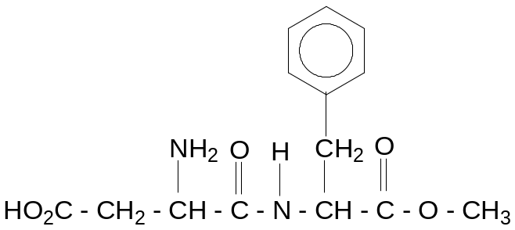
 |  | (i) | Name the functional groups present in Aspartame.
 |  | (ii) | Describe a simple chemical test by which you could identify one of the functional groups in Aspartame.
 |  | (iii) | Draw the structural formula of Aspartame that would exist at pH 3.
 |  | (iv) | Aspartame can be prepared through a series of reactions starting with amino acids. Give the structural formula of the amino acids that could be used to prepare Aspartame.
 |  | (v) | Describe the types of R group interactions that could exist for each of the amino acids identified in b(iv).
 |  |  |  | [9]
 | (c) | The HPLC chromatogram of the food additive mixture shows that it contains salicylic acid (2-hydroxybenzenecarboxylic acid) and benzenecarboxylic acid.
 |  | (i) | You are given separate samples of these two acids, dissolved in a suitable solvent. State a chemical reagent that will distinguish between these two acids, giving the result of the test in each case.
 |  | (ii) | 2-hydroxybenzenecarboxylic acid can be prepared from phenol. Suggest a route for this conversion.
 |  |  |  | [4]
 | (d) | The chromatogram also shows the presence of sorbic acid (hex -2,4-dienoic acid), CH₃CH=CH-CH=CH-COOH. Draw diagrams to illustrate the several different geometrical isomers of hex-2,4-dienoic acid.
 |  |  |  | [2]
 |  | [Total: 20]

5 | (a) | (i) | The oxides of sodium, silicon and phosphorus differ in their bonding and their reactions with water.  Describe these reactions, relating them to the structure and bonding in each oxide. Write equations where appropriate and suggest the pH of any aqueous solution formed.
 |  | (ii) | Account for the difference in melting points of oxides of silicon and phosphorus.
 |  | (iii) | An element in the second period in the Periodic Table often shows a diagonal similarity to the element a group higher in the third period. Beryllium shows similar chemical properties to aluminium.  Write equations for the reaction of BeO to illustrate its amphoteric nature.
 |  |  |  | [10]
 | (b) | (i) | Write an equation, including state symbols, for thermal decomposition of Group II nitrates, M(NO₃)₂.
 |  | (ii) | Draw and name the shape of the nitrate ion.
 |  | (iii) | By quoting relevant values from the Data Booklet, describe and explain how thermal stability of the nitrates of Group II metals varies from magnesium to strontium.
 |  |  | A Group II nitrate exists as a hydrate M(NO₃)₂.xH₂O. On heating, 1.80 g of this hydrate lost 0.55 g in the form of steam, as it was converted into the anhydrous nitrate M(NO₃)₂. Subsequent heating to constant mass produced a white residue and gases. The gases produced were passed through aqueous sodium hydroxide. The resultant gas occupied 95 cm³ at 101 kPa and 30°C.
 |  | (iv) | Calculate the number of moles of resultant gas formed.
 |  | (v) | Hence, calculate the value of x and deduce the identity of metal M.
 |  |  | [10]
 |  |  | [Total: 20]

